**ONBOARDING**

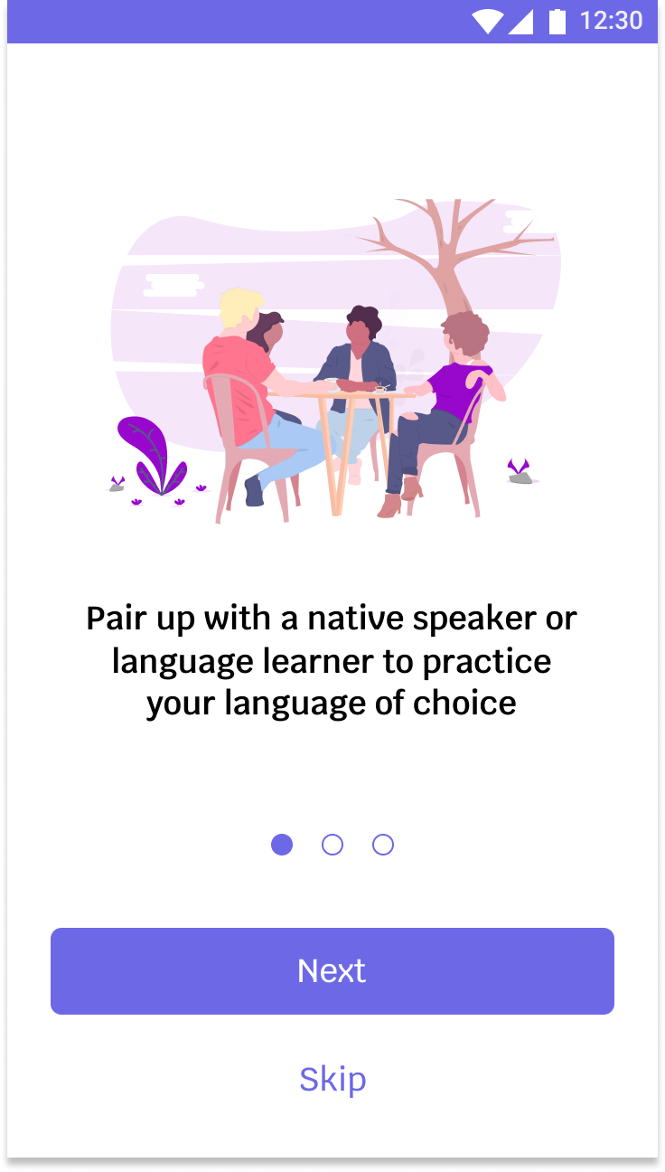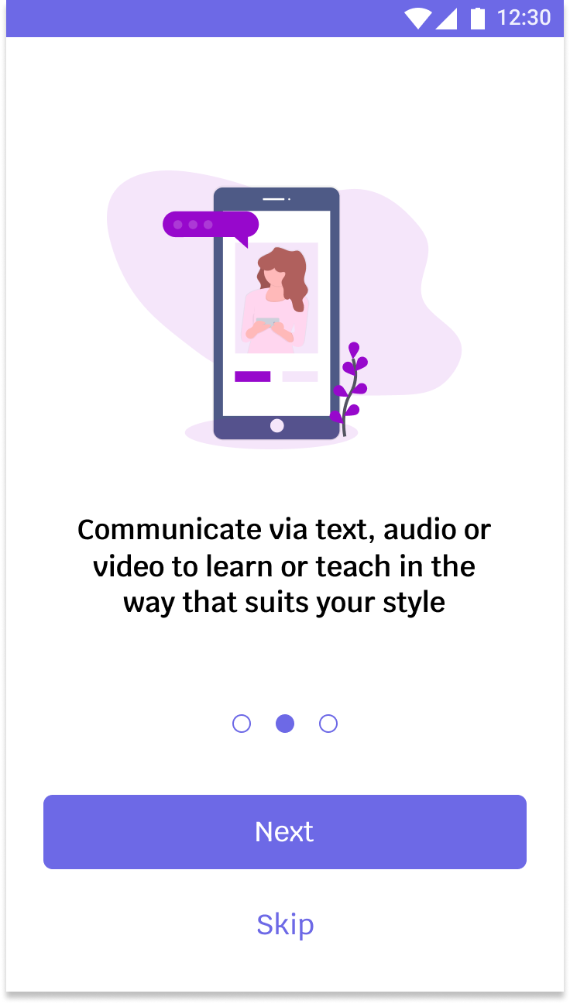

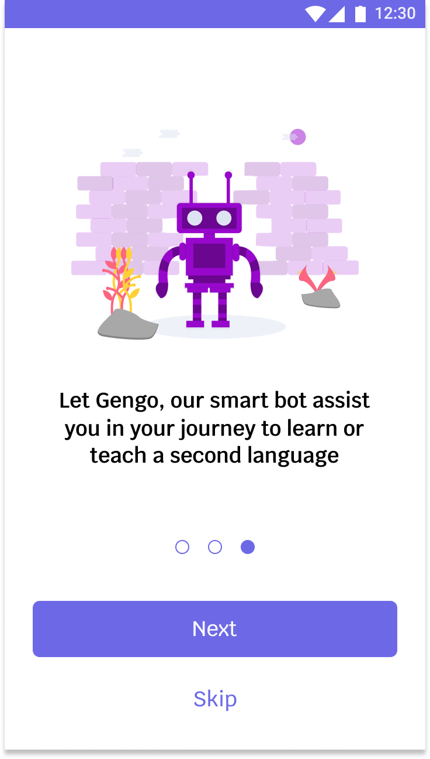

The above screens give an overview of what the application is about to to new users. It tells about the purpose of the application, the different communication methods available to them and the presence of a chatbot to assist them in learning a second language.

**LOGIN**

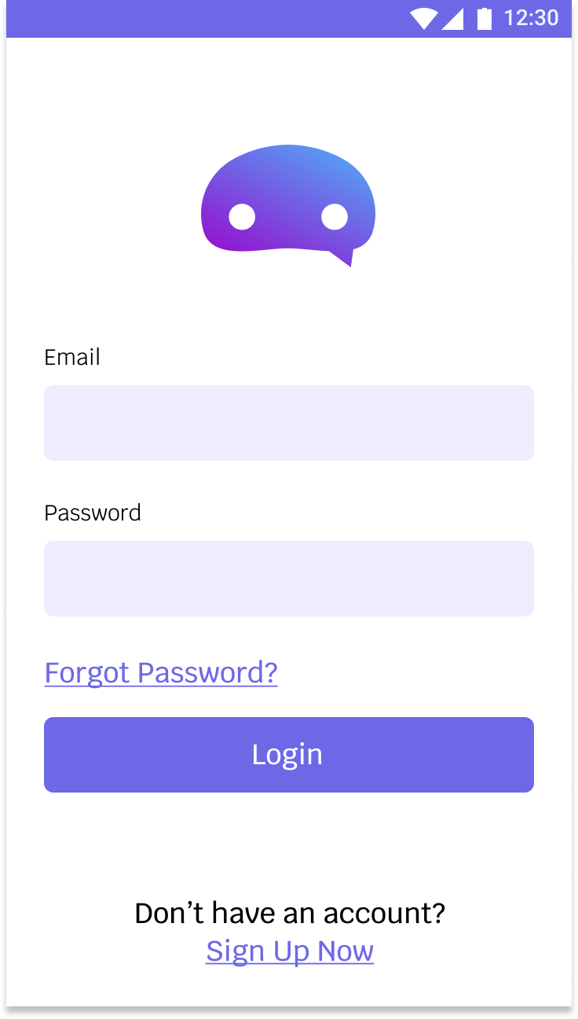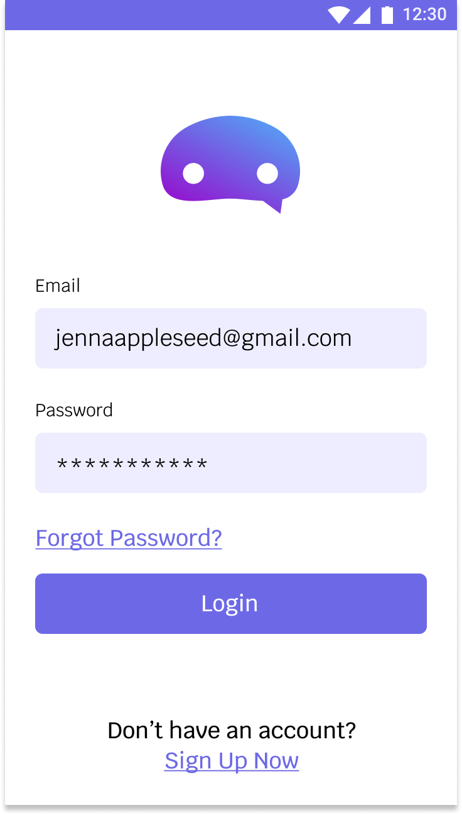

The usual log in screen where a user can enter their login credentials or sign up if they are a new user.

**INTRODUCING GENGO THE BOT**

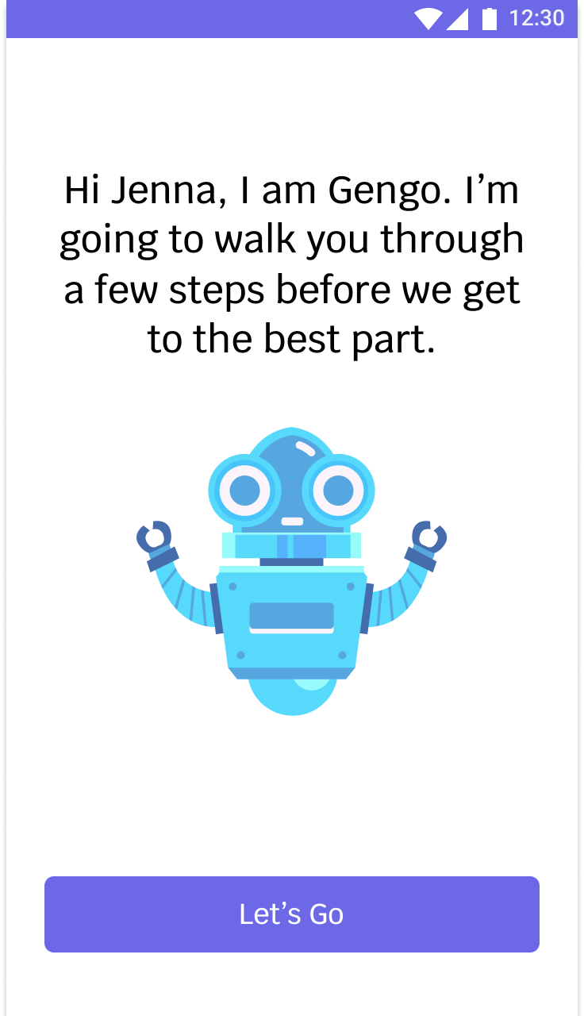

Gengo, the avatar for the bot in the application, introduces himself and takes the user through a series of steps to create their profile. Since the focus is on language learning, a decision was made to provide a conversational approach to onboard the user.

**PROFILE CREATION**

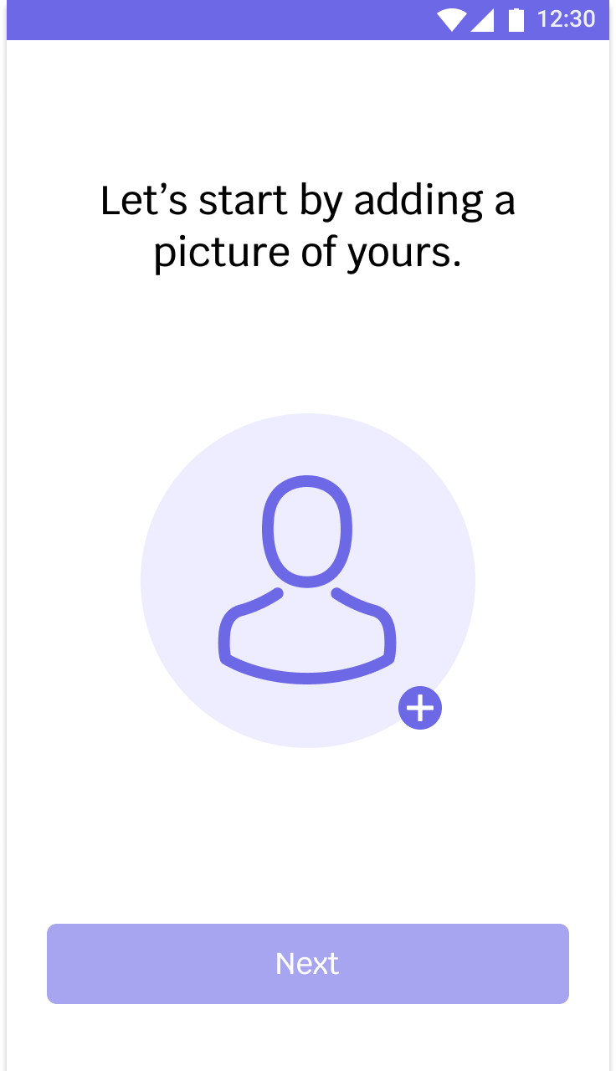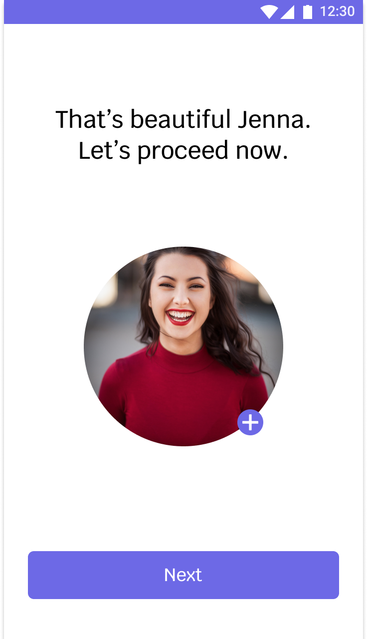

The first step in a series of steps to set up their profile, the user is asked to add a profile picture. The presence of a real photo provides a sense of trust and gives a better connection when communicating with a person, especially someone they are talking to for the first time.

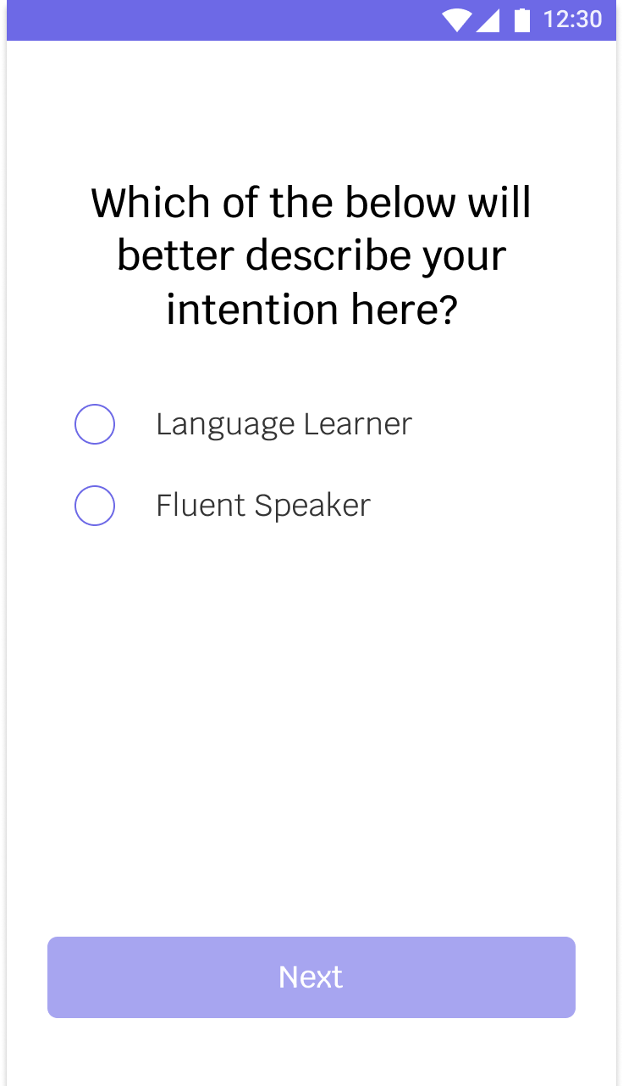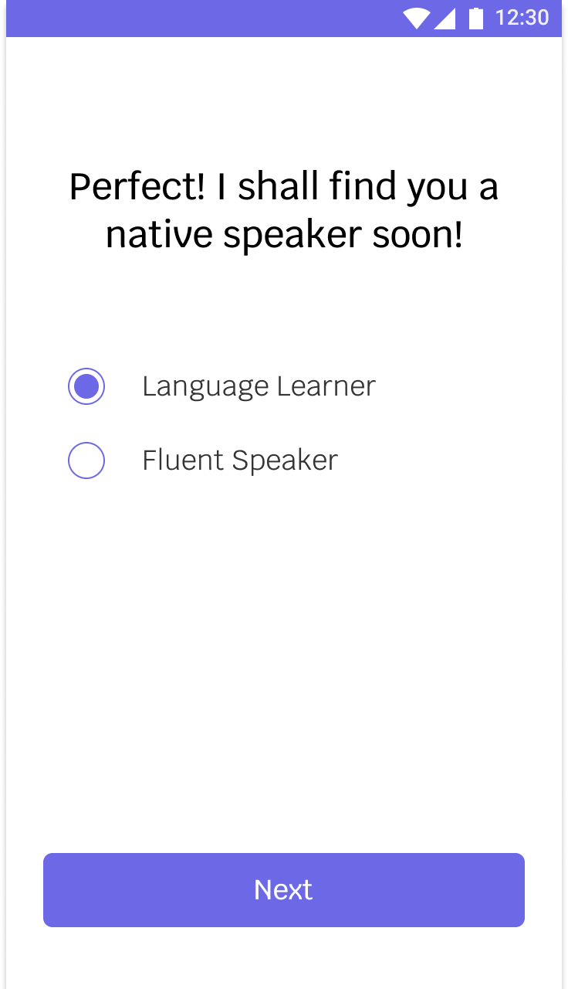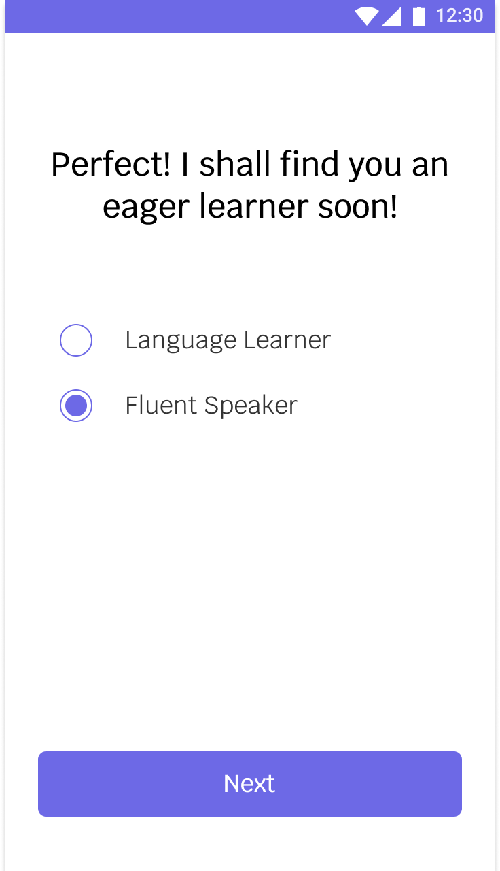

The user is then asked whether they would like to be a language learner and learn practice a second language or be a fluent speaker and help a learner practice the language.

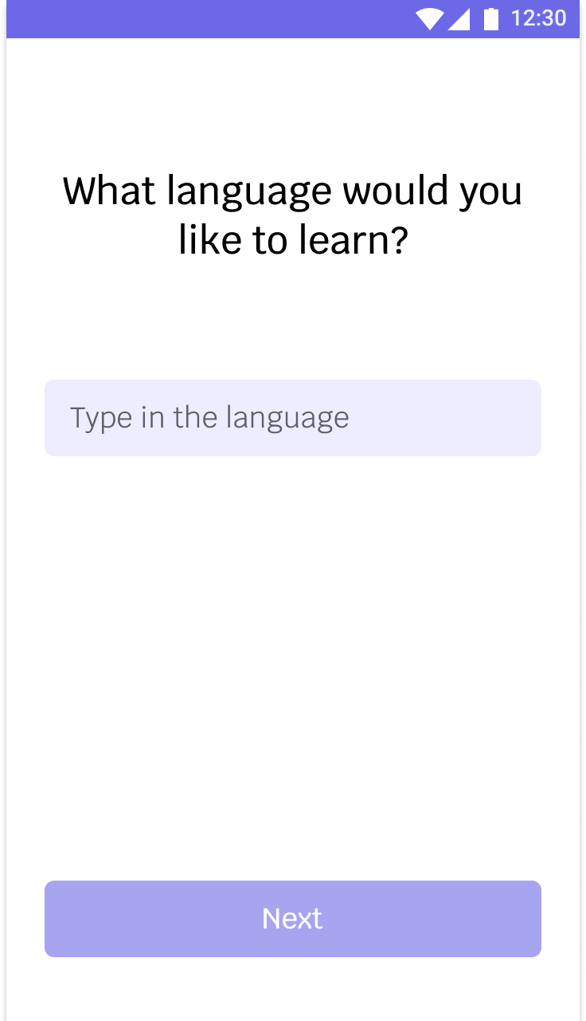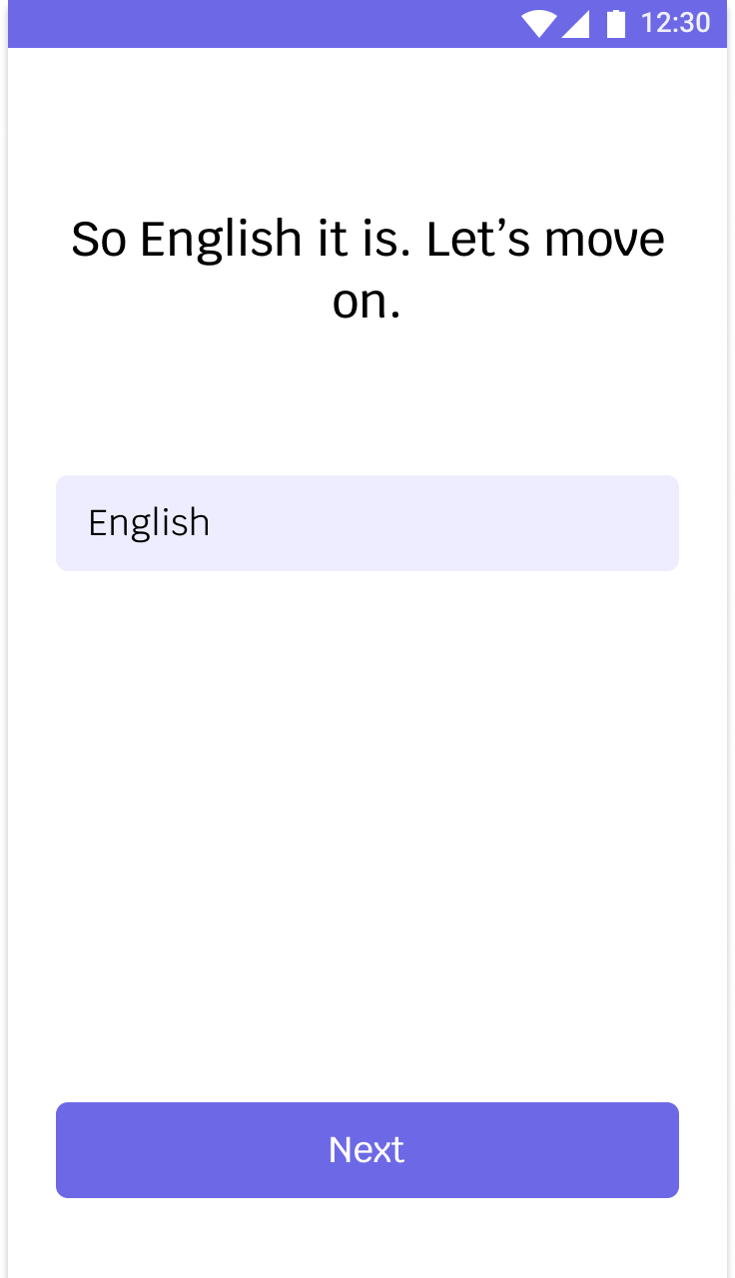

The next step is to find out what language the learner would like to learn.

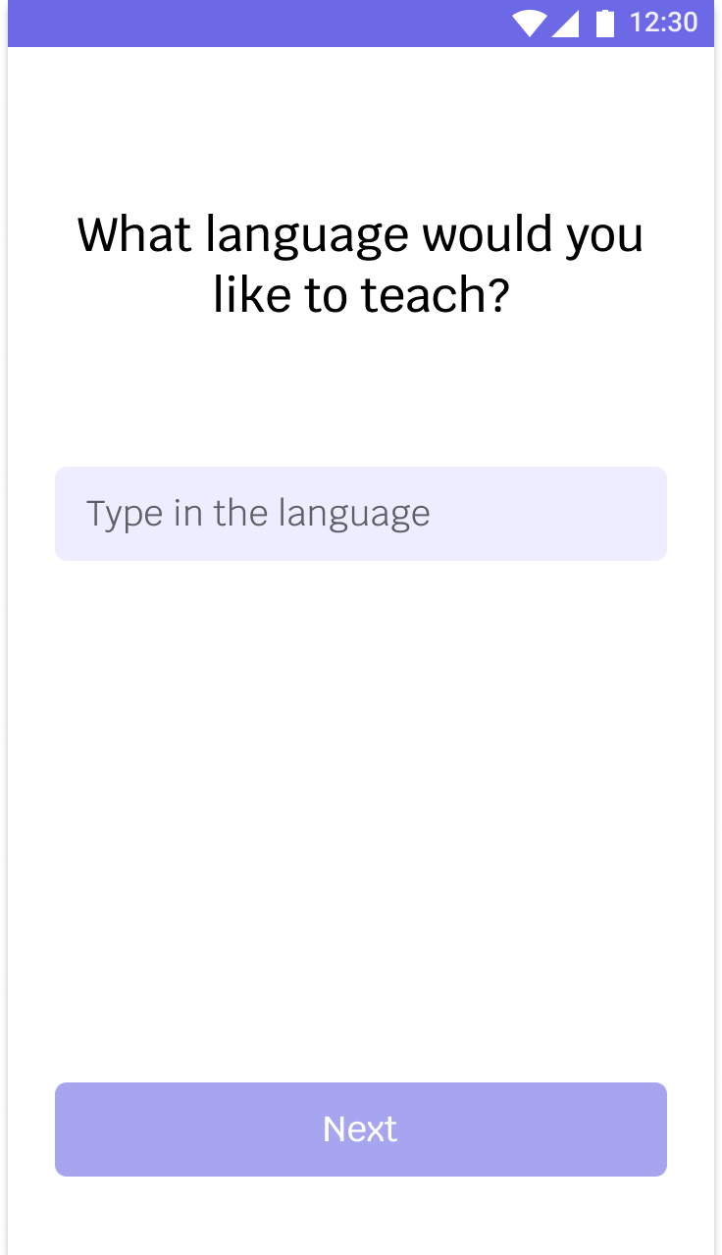

A fluent speaker will be asked a similar question as a learner but in the context of the which language they would like to teach.

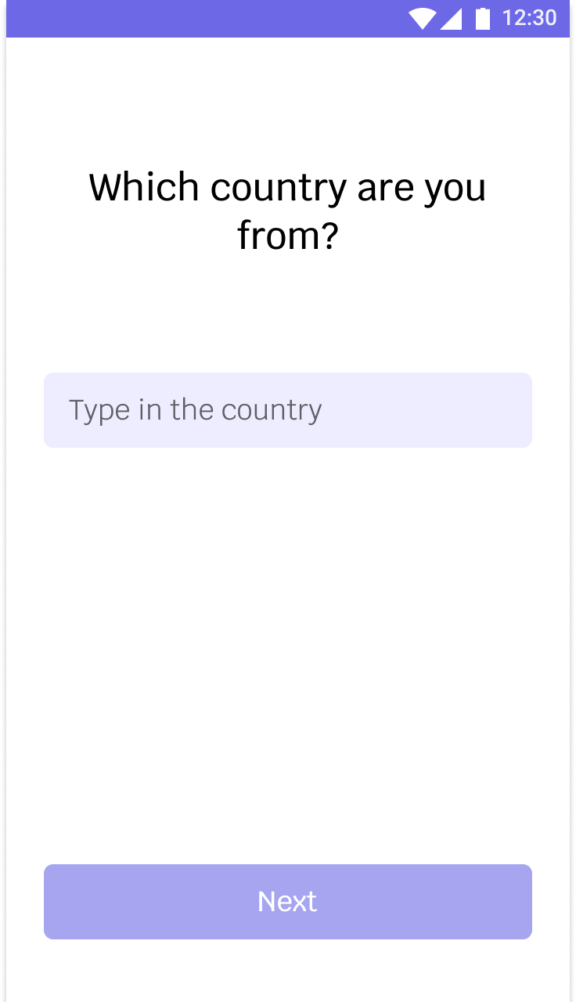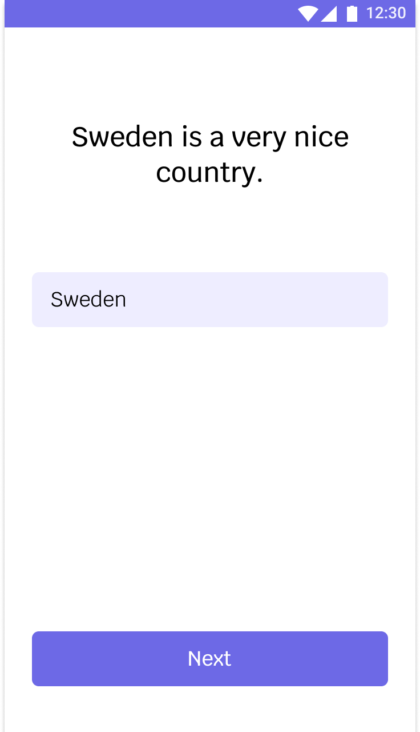

The next step is finding out which country the person is from. From our research, people wanted the choice of deciding which country their pair should be from. And hence this was added into the profile creation process.

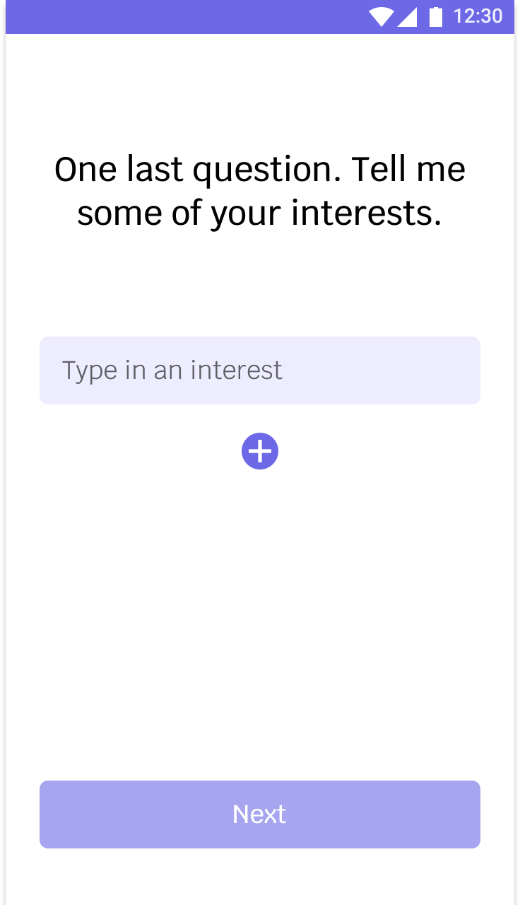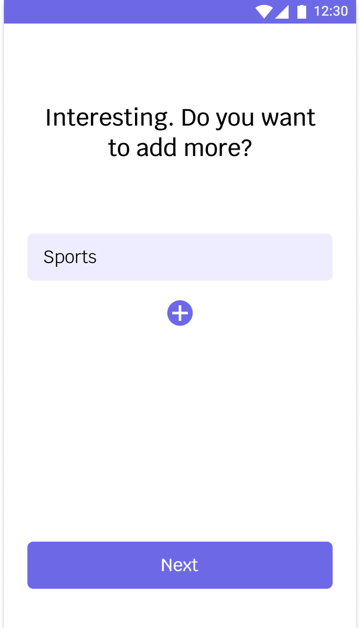

Users are asked to add in their interests. The pairs are matched on the basis of interests. Common interests leads to better conversations and hence better language learning.

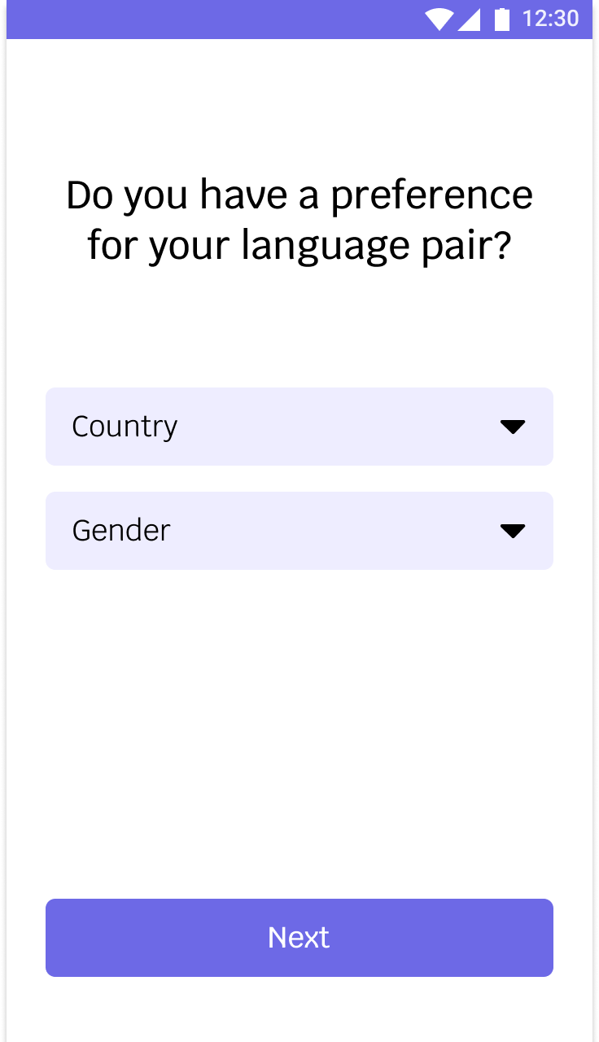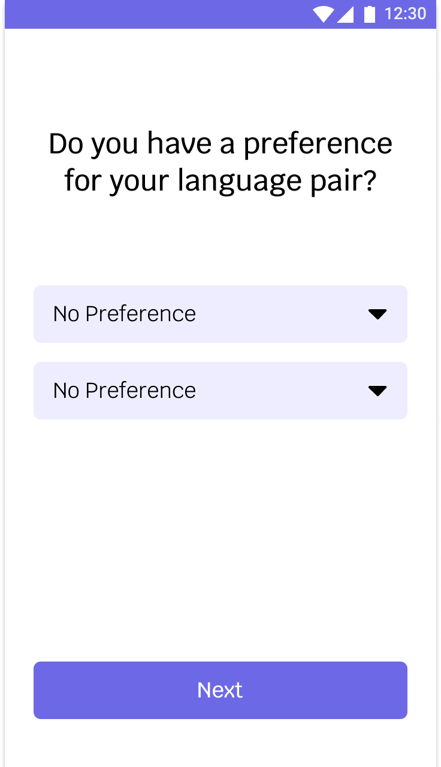

From our research, users wanted the choice of filtering who their pair should be. This was especially in the context of gender. Hence the choice of selecting the country of origin and gender.

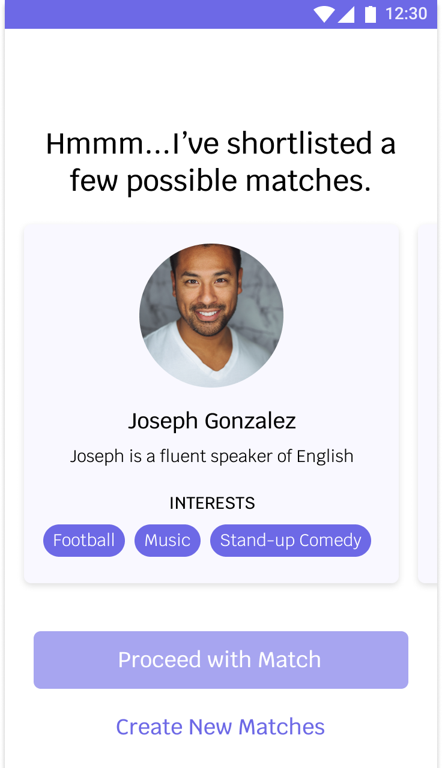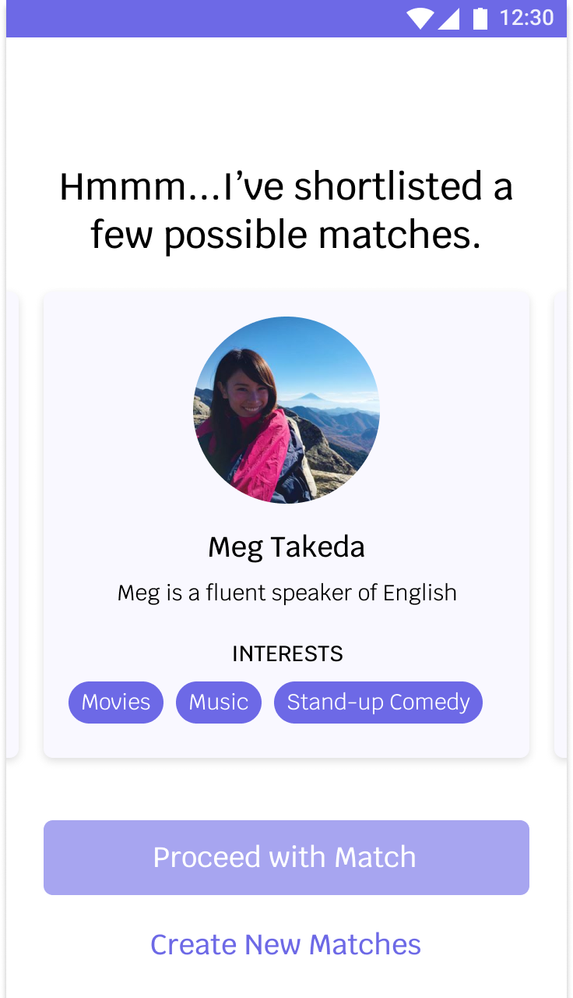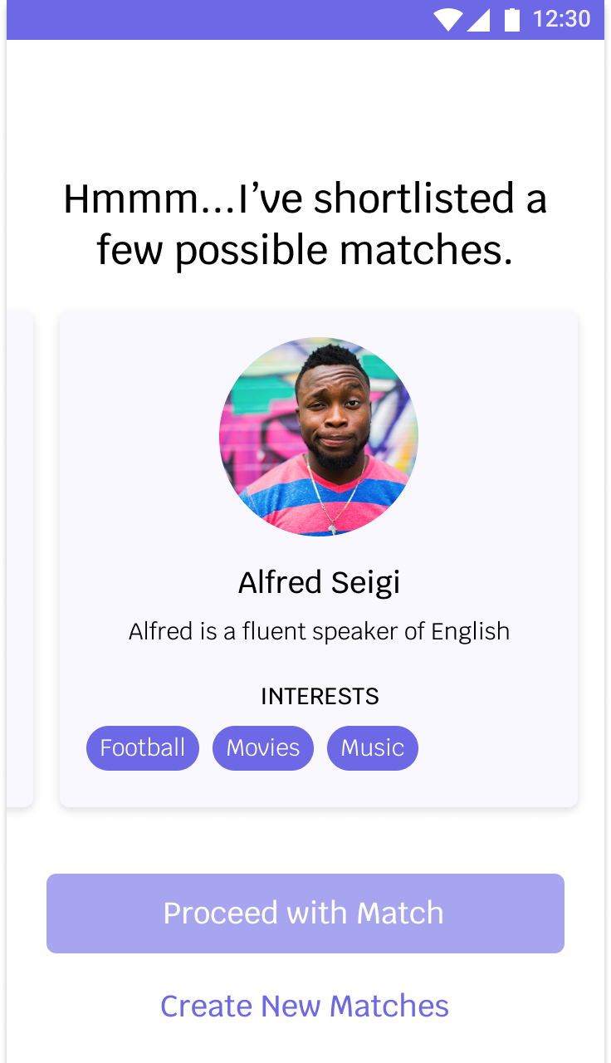

Language learners are given the choice of selecting from 3 possible matches. If the matches don’t suit their liking, they can request for a new set of matches to be generated. Once the learner selects a suitable match, the fluent speaker gets notified for acceptance.

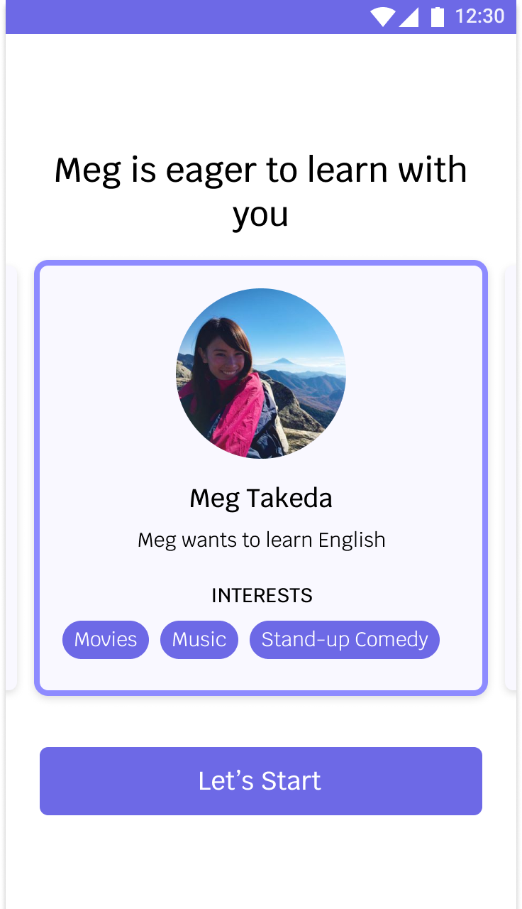

Once a language learner selects a pair, the fluent speaker gets notified of the interest expressed and is required to accept to initiate the conversation.

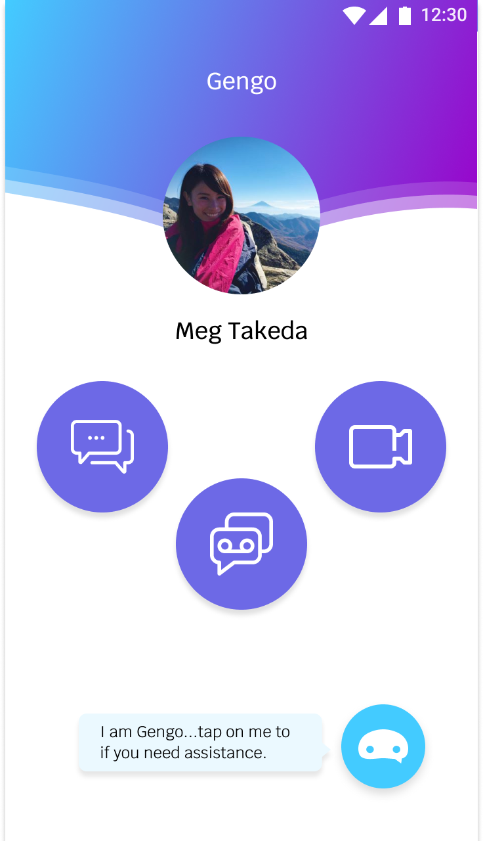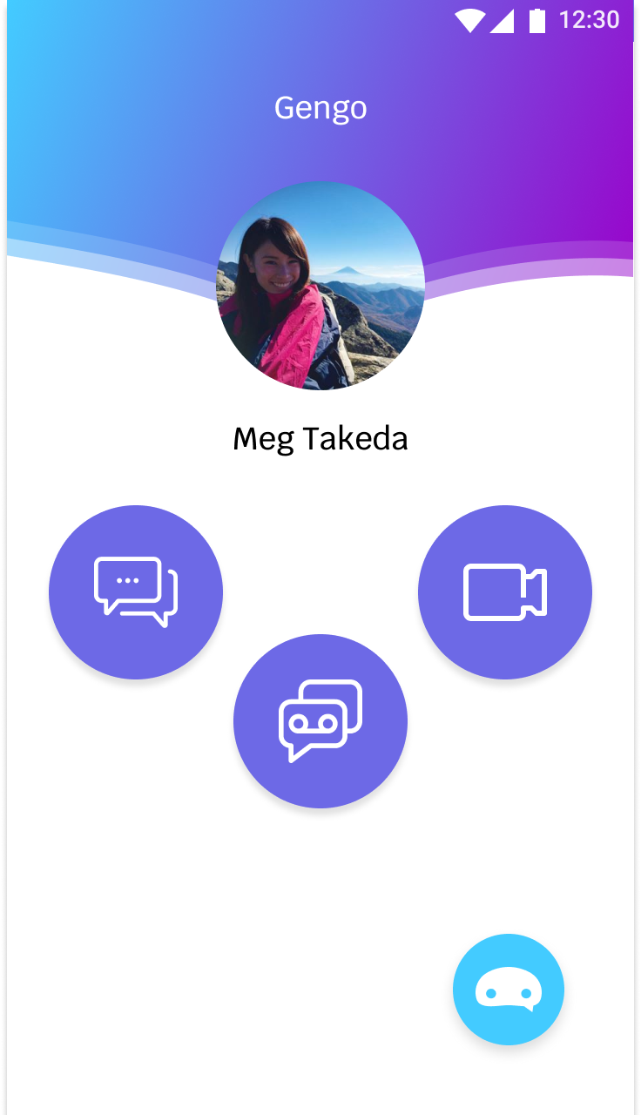

The pair have 3 different communication methods, i.e. text message, voice message and video call. These are to give them control of choosing a convenient method depending on their space and place.

A chatbot is present to assist them in language learning or teaching.

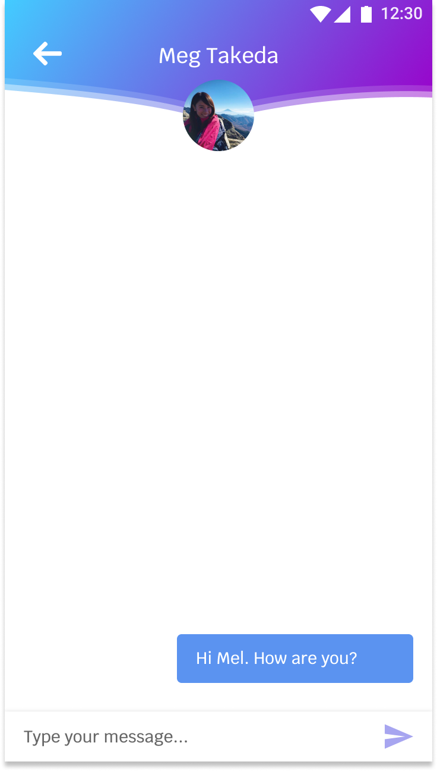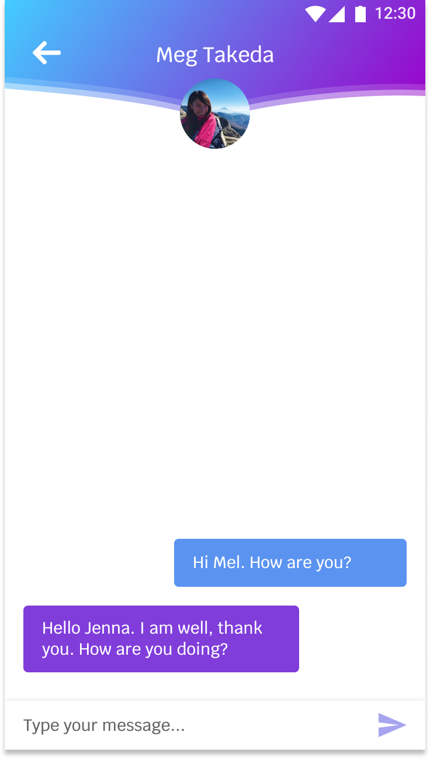

The pair is able to communicate via text messages.

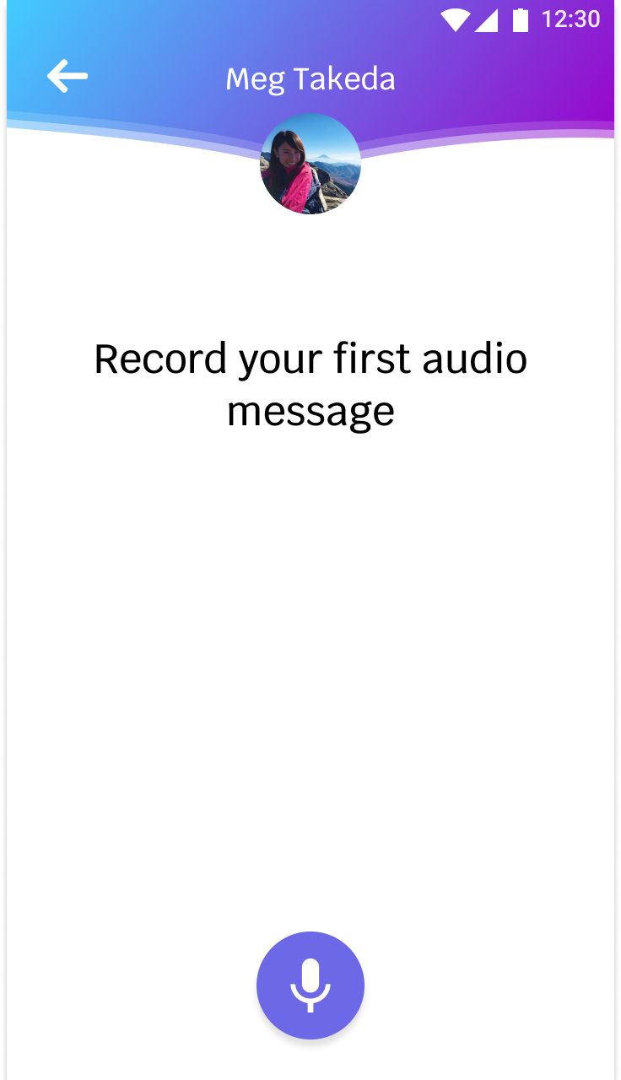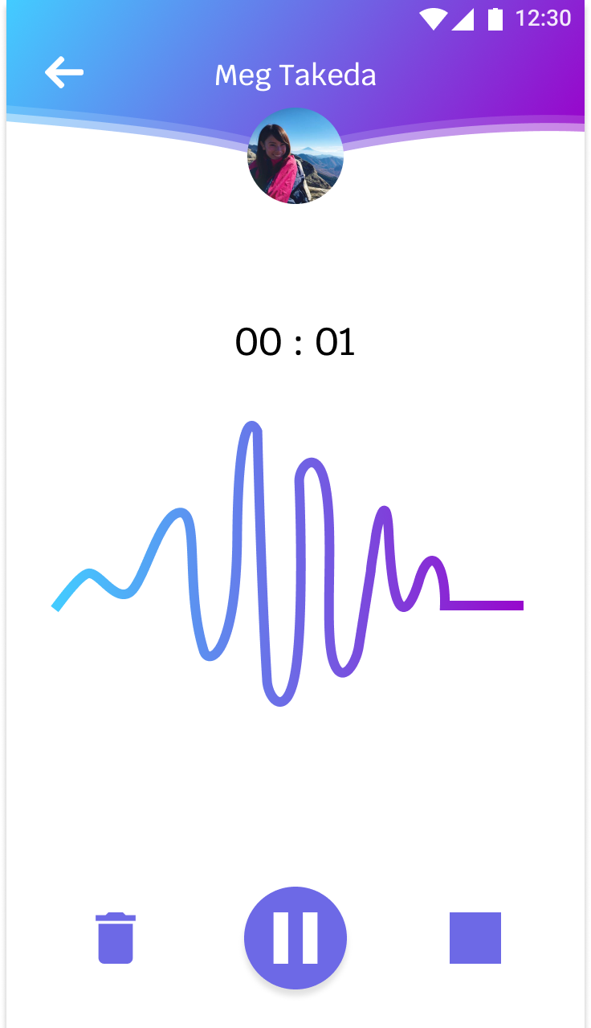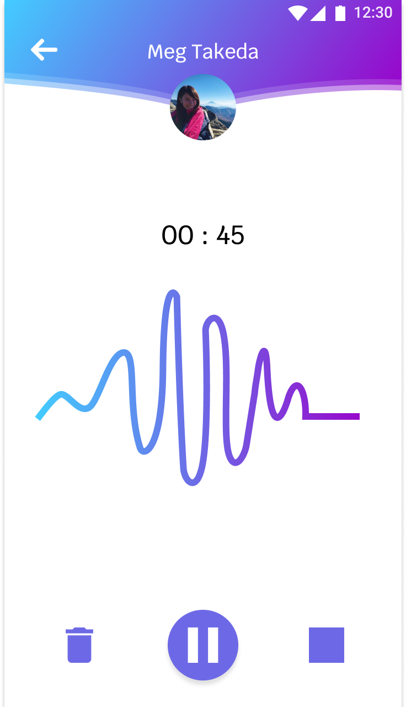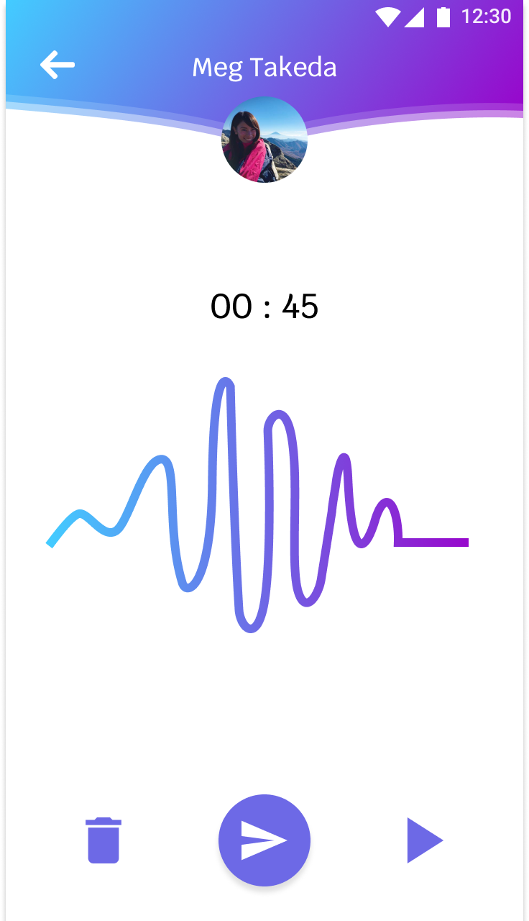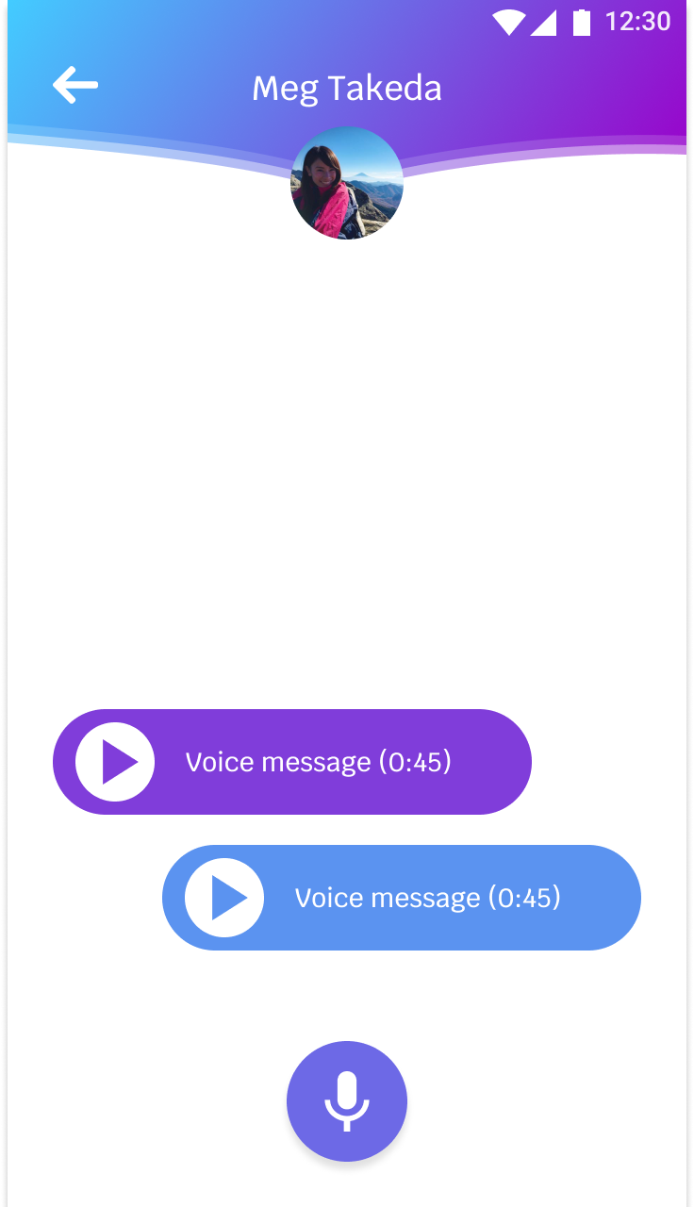

The pair is able to send each other voice messages. They can test the message prior to sending by playing it.

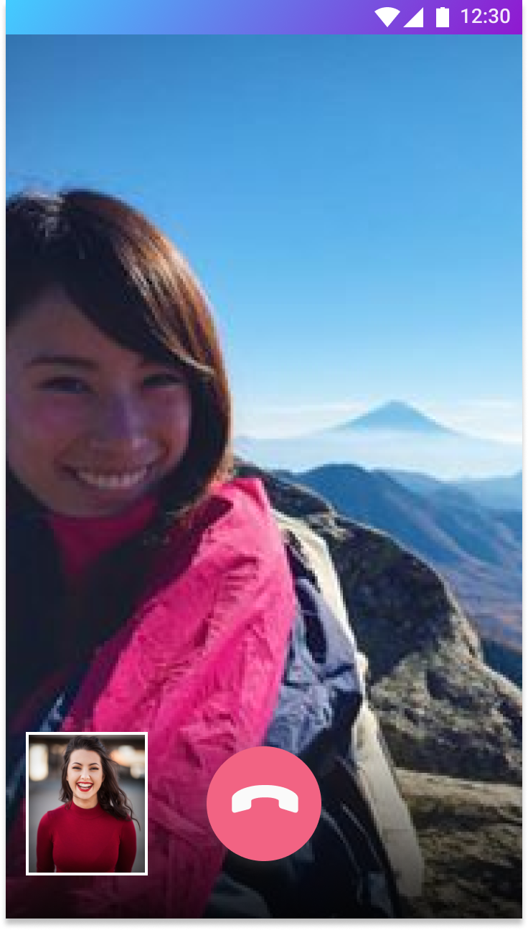

The pair can initiate a video call and have a synchronous or real-time communication when they feel to.

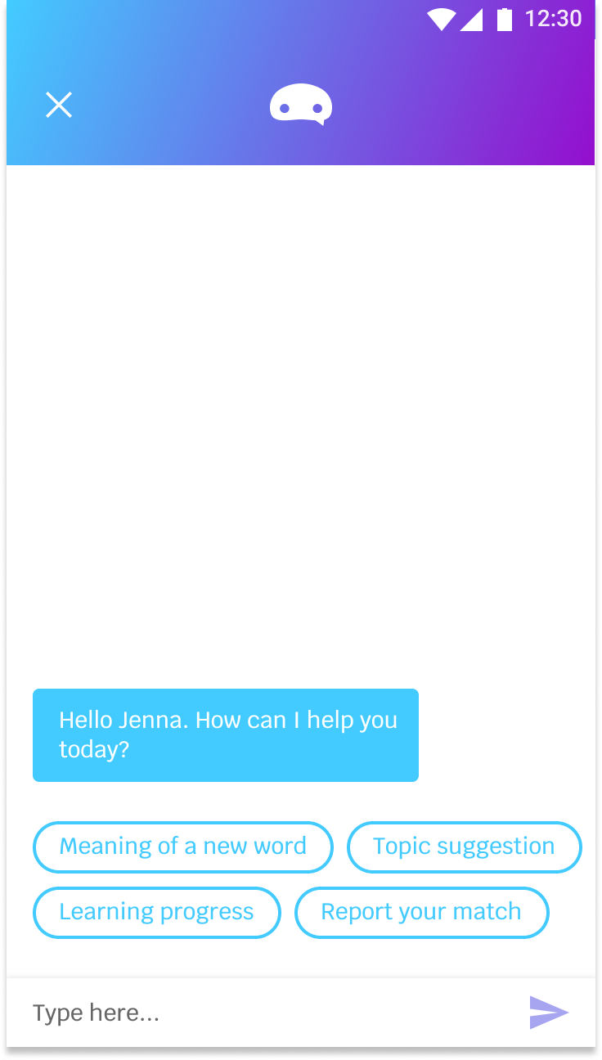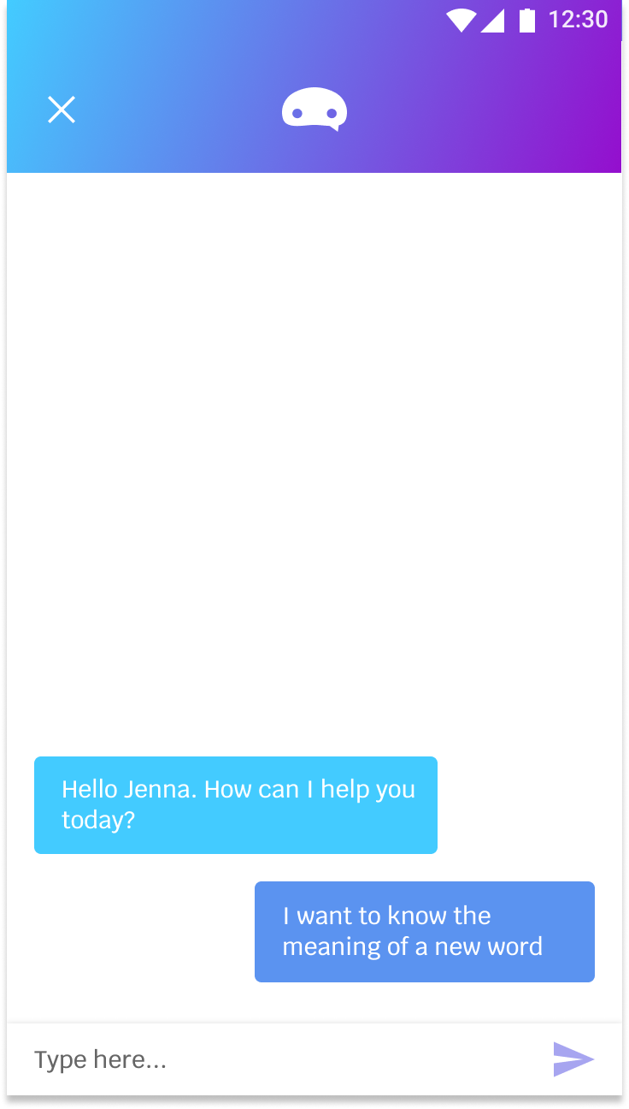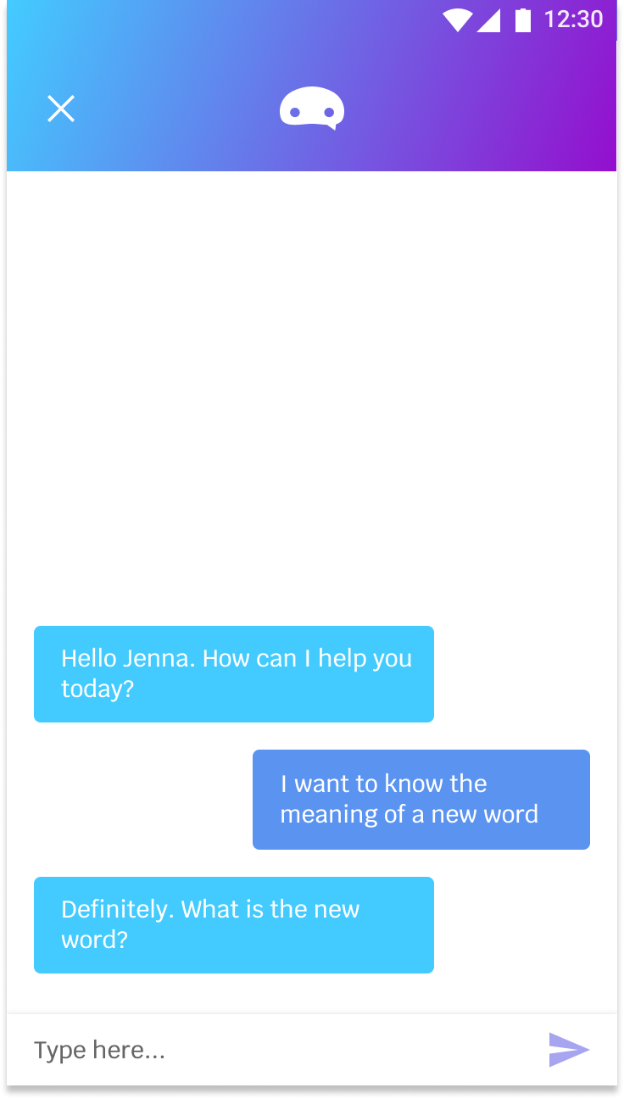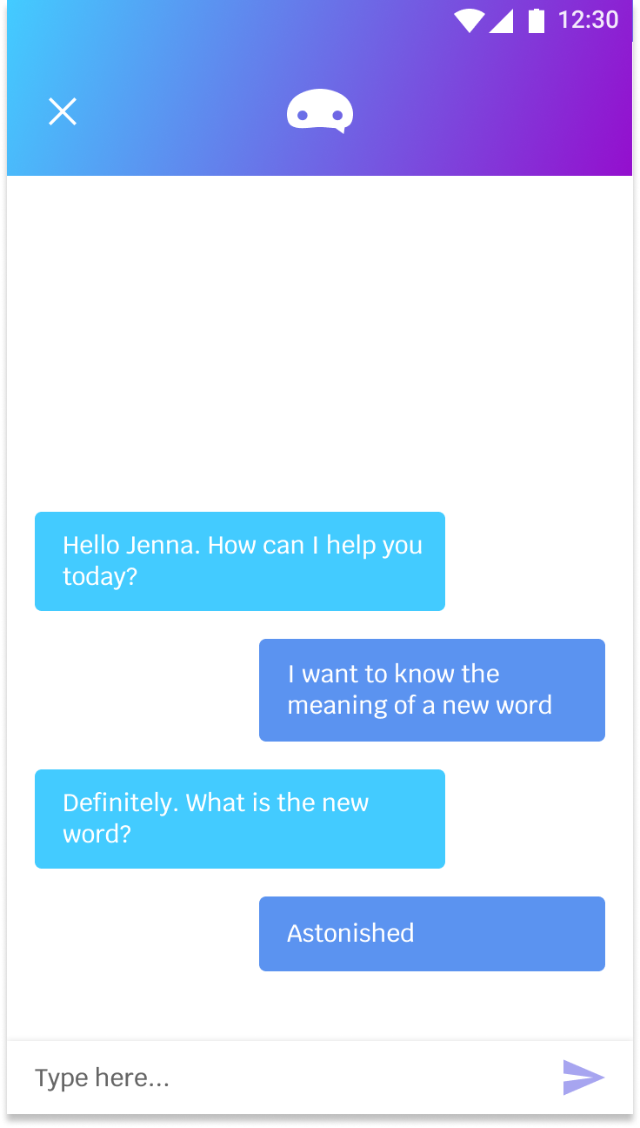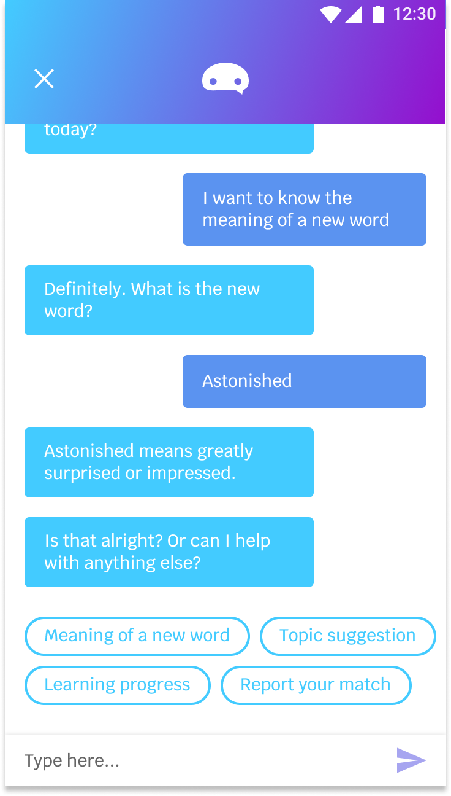

The user can initiate a conversation with the chatbot when they feel the need to. The above screens show the flow of a language learner initiating a conversation to find out the meaning of a new word used by the fluent speaker.

PROTOTYPE LINK:

<https://marvelapp.com/a2j3jg0>

PROTOTYPE LINK USED AT SHOWCASE:

<https://marvelapp.com/478762d>